LAB 7

Q1,Q2
- Import the dataset "Salaries.csv".

2) Display how many rows and how many columns and Display first 10
rows and last 15 rows.

OUTPUT:
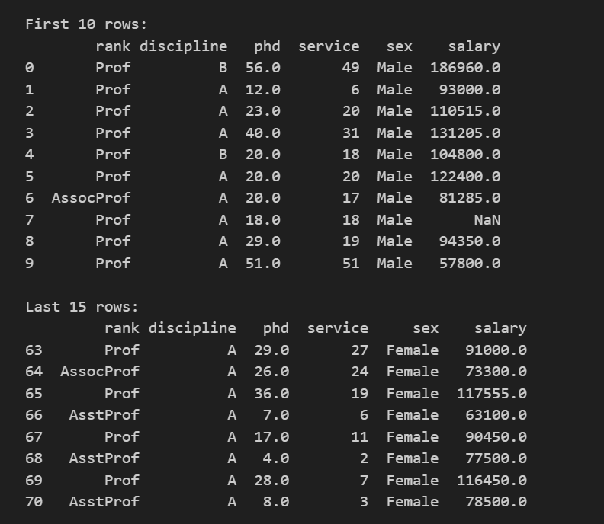
- Which Male and Female Professor has the highest and the lowest salaries?
OUTPUT:
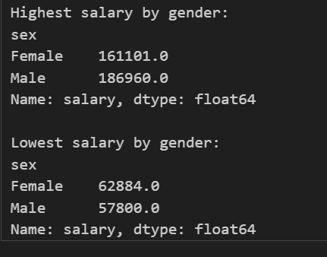

- Which Professor takes the highest and lowest salaries?
OUTPUT:

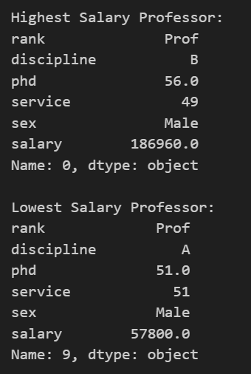
5) Missing ‘Salaries’ - should be replaced as mean of the matching salaries
of those whose ‘ service’ is the same
OUTPUT:

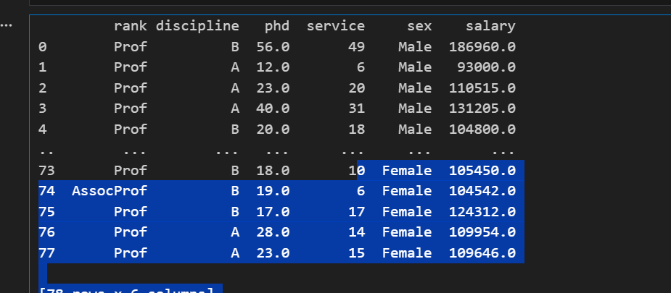
- Missing ‘phd’ - should be replaced as mean of the matching ‘service’
OUTPUT:

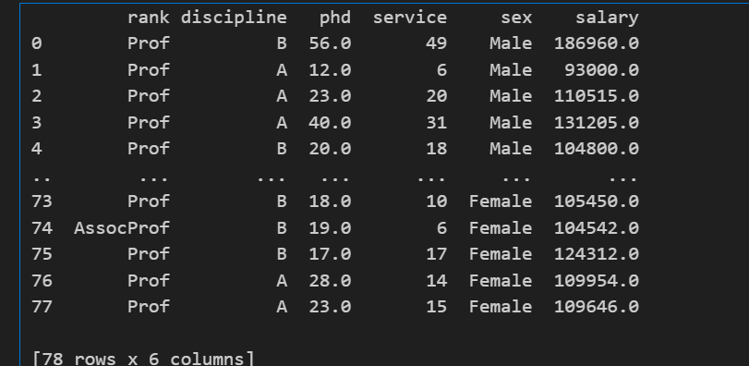
7) How many are Male Staff and how many are Female
Staff. Show both in numbers and Graphically using Pie
Chart.
OUTPUT:

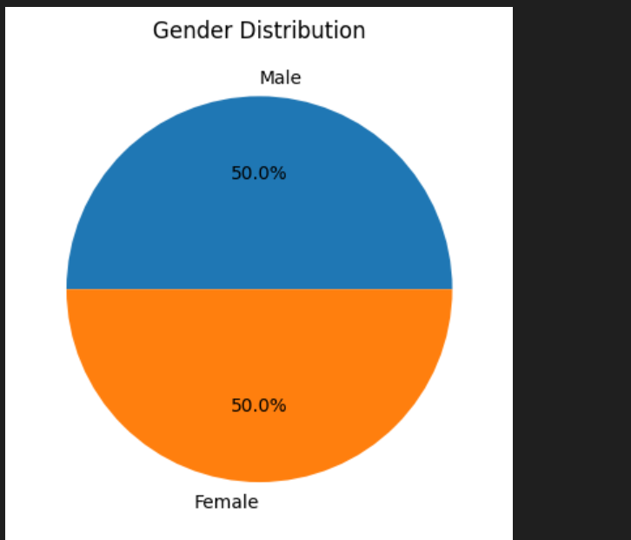
8) How many are Prof, AssocProf and AsstProf. Show both in numbers and
Graphically using a Pie Chart.
OUTPUT: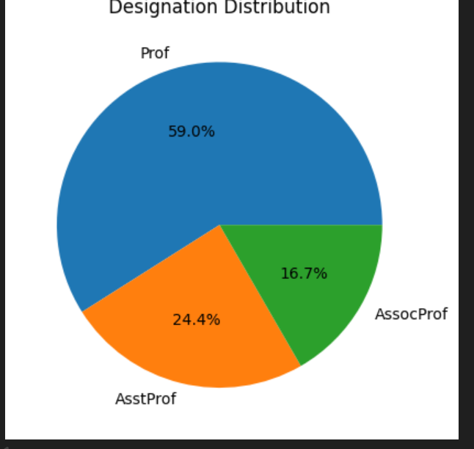

- Who are the senior and junior most employees in the organization.
OUTPUT:

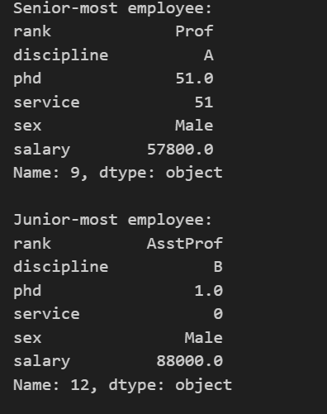
10) Draw a histogram of the salaries divided into bin starting from 50K and
increment of 15K
OUTPUT:
